**SIR APOLLO**

**END OF TERM III EXAMINATION 2023**

**P.4 MATHEMATICS**

***Time Allowed: 2hours 30 Minutes***

**Pupil’s Name: …………………….……………………………………**

**Class: ………………………………….……………………………………**

**School Name: ……………………………………………………………**

|  |  |  |
| --- | --- | --- |
| **FOR EXAMINERS’**  USE ONLY | | |
| **Qn. No.** | **MARKS** | **EXR’S**  **No.** |
| **1 - 10** |  |  |
| **11 – 20** |  |  |
| **21 – 30** |  |  |
| **31 – 32** |  |  |
| **TOTAL** |  |  |

**Read the following instructions carefully:**

1. This paper has two sections: **A** and **B**
2. Section **A**has 20 short questions (40 marks)
3. Section **B** has 12 questions (60 marks)
4. Answer all questions. All the working for both sections A and B must be shown in the spaces provided.
5. All working must be done using a blue or blackball point pen or ink. Any work done in pencil will NOT be marked except drawings and diagram.
6. Unnecessary changes in your work and handwriting that cannot be easily read may lead to loss of marks.
7. Do not fill anything in the table indicated

**“For examiners’ use only”** and the boxes inside the question paper.

**Turn Over**

**SECTION : A (40 Marks).**

1. Add : 2 4

+ 5

2. Name this set symbol



3. What number is shown on the abacus?

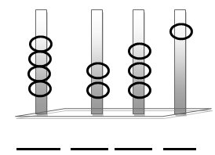

4. Given that K = {a, e, i, o,u}

Find n(K) =

5. Expand 7043 using values.

6. Find the area of the figure below.

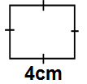

7. Find the LCM of 3 and 6

8. Simplify: 5p + 2p + p.

9. Describe the shaded part in the Venn diagram below.

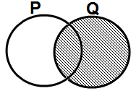

10. Find the missing number to make the part of fraction equivalent.

2 =

10 40

11. Abdul had sh. 2500. He bought sweets worth sh. 1200. How much money was he left with?

12. How many hours are in 180 minutes?

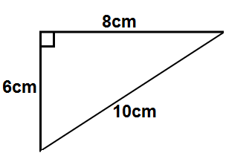13. Find the total distance around the shape below.

14. List all the factors of 12.

15. Round off 820 to the nearest hundreds using the number line below.

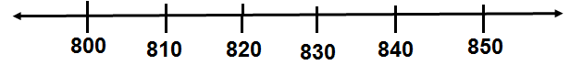

16. Work out: **m cm**

5 47

+ 8 13

17. A parent had 24 oranges. She shared them equally among 4 children. How many oranges did each get?

18. Draw clock face and show a half past 6’ oclock.

19. Multiply : 1 5

x 1 3



20. Melisa had of an apple. If she ate of it. What fraction of the apple was left?

**SECTION : B ( 60 Marks)**

21. Work out the following;

a) y + 5 = 13 (2mks)

b) x – 6 = 5 (2mks)

c) 5 m = 20 (2mks)

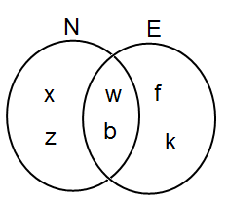22. The Venn diagram below shows sets E and N. Study it carefully and use it to answer the questions that follow.

Find ; i) E ∩ N. (1mk)

ii) E U N. (1mk)

iii) n (N) (1mk)

23. Using the signs >, < or =, complete the statements below correctly.

i) XIX ____________ XX (1mk)

ii) 2 x 3 _____________ 2 +3 (1mk)

iii) 1 ____________ 1 (1mk)

2 4

iv) 500g _____________ 1kg (1mk)

24. Joseph is 12 years old. Simon is 18 years old.

a) Find their total age. (2mks)

b) Find the difference in their ages

(2mks)

c) How old will Simon be in 4 years time? (2mks)

25a) Add: **Wks days**

7 5 (2mks)

+ 2 3

b) Subtract: m cm

4 55 (2mks)

- 1 80

c) Convert 600cm to metres.

(2mks)

26. The figure below is a rectangle. Use it to answer the questions that follow.

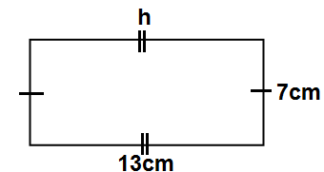

i) Find the value of h. (1mk)

ii) Calculate its area. (2mks)

iii) Find the perimeter of the rectangle above. (2mks)

27a. Which number has been expanded below.

(2 x1000) + (4 x 100) + (7x10)?

(2mks)

b) What is the place value of 3 in the numeral 1346? (1mk)

c) Write the figure “fifteen thousand five hundred twenty one”. (2mks)

28a) Write the following in Roman numerals.

i) 25 (1mk)

ii) 17 (1mk)

b) Draw the following shapes,

ii) Semi-circle (1mk)

iii) Cylinder. (1mk)

29. Given the number 3678.

a) Find the place value of 7 in the number. (1mk)

b) Calculate the values of 8. (1mk)

c) Find the sum of the value of 6 and 3 in the number. (2mks)

30. Here is the price list of some items in Tofa’s supermarket. Use it to answer the questions that follow.

|  |  |
| --- | --- |
| **ITEM** | **PRICE** |
| A pencil | sh. 500 |
| A book | sh. 700 |
| A ruler | sh. 500 |
| A rubber | sh. 800 |
| Ball point pen | sh. 5000 |

a) How much would you pay for a book and a rubber? (2mks)

b) Which two items cost the same amount of money? (2mks)

c) Kizito bought 2 rulers, how much did he pay? (2mks)



31a) Add : 3 + 3

7 7 (2mks)

**END**

b) Subtract : - 5 (2mk)

8

c) Change 12 into a mixed fraction

5 (2mks)

32. Mbabazi scored the following marks in end of September exams.

**English 70**

**Mathematics 83**

**Social studies 92**

**Science 94**

a) In which subject did he get the highest mark? (1mk)

b) Find the difference between the highest and the lowest mark.

(2mks)

c) Find the total marks in all the subjects.

(2mks)